Software Requirements
- Functional Requirements
  - Users can sign up and login
  - Users can add logs for activity, mood and food intake
  - Users can access log history to view previous records
  - Users can see that show trends and analytics from the past 7 days
  - Users can delete old records

- Non – functional Requirements
  - There are no overlapping elements in the dashboard
  - Overview shows quick reference for Steps taken, Calories burned, Calories Consumed and Water Intake
  - No errors when logging activities (e.g. cannot enter alphabetical values in a numerical field)
  - Users can sort log history by record type
  - Check if the software can be used on different resolutions, so that it can be transferred to different device types

Prototype 1
Test | Steps | Result | Image(s)
Signup and login | - Enter username and password and click signup | No signup or login screen | -
Create activity log | - Click the + Activity button  - Choose activity type  - Check date  - Enter activity name  - Enter activity details  - Save record | Activity record is saved and user is automatically redirected to the dashboard | 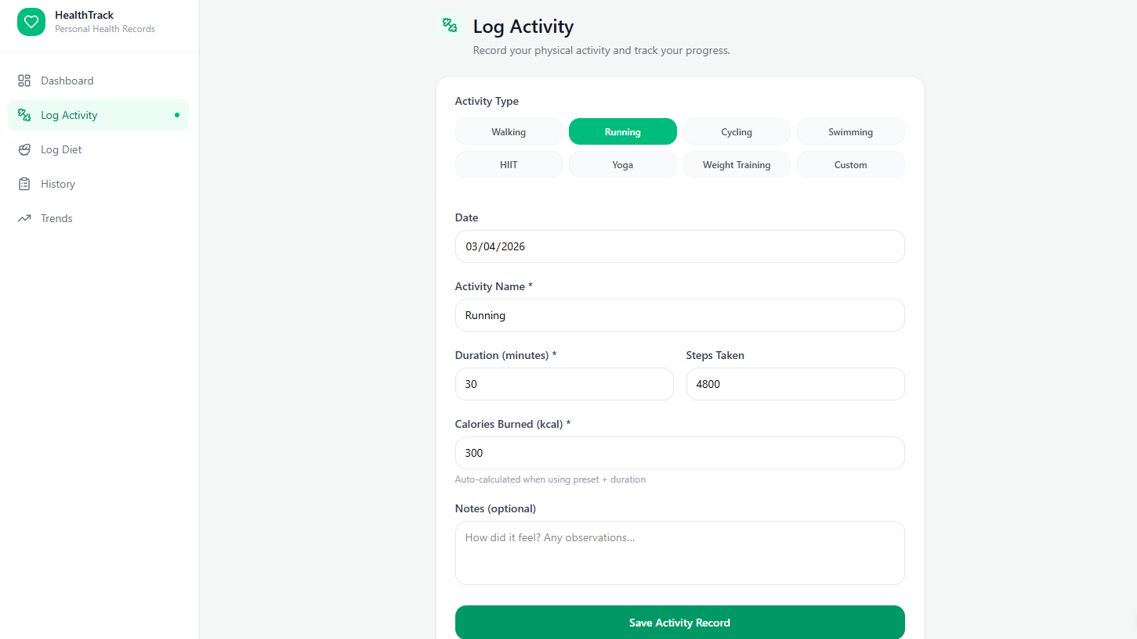
Create mood log | - | No function for creating mood log | -
Check history log | - Click the History tab | User is directed to the history page, where they can access old records | 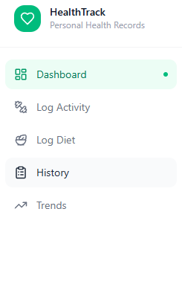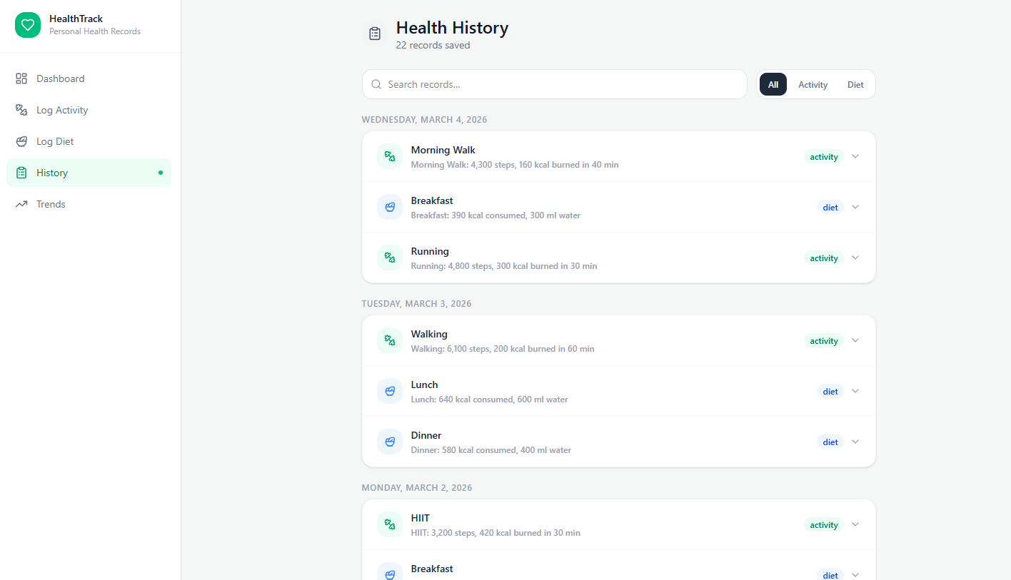
Delete old records | - Click any record  - Click delete record  - Confirm delete | Record is deleted and data is reflected correctly | 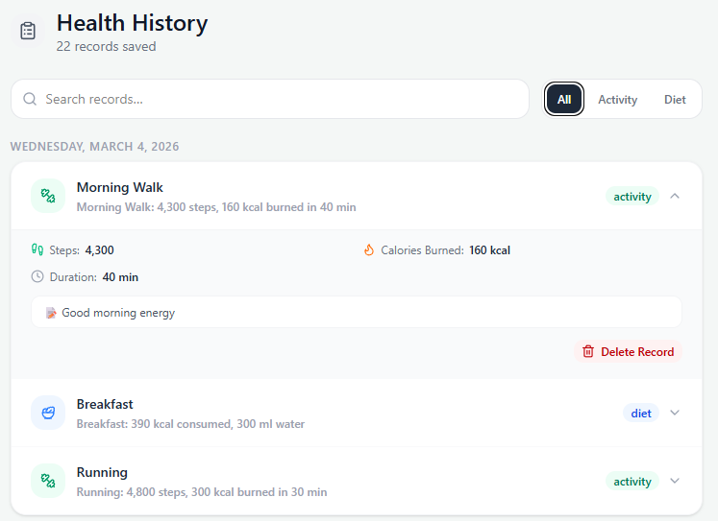
Trends and analytics are shown correctly | - Click Trends tab  - View charts | Data is not shown even though there is data in the system.  Charts are empty, except for pie charts. | 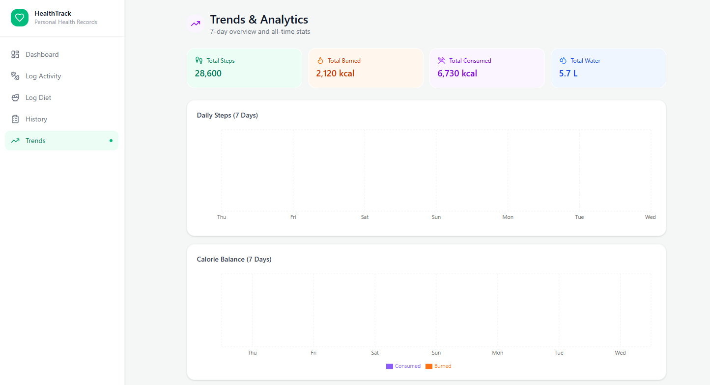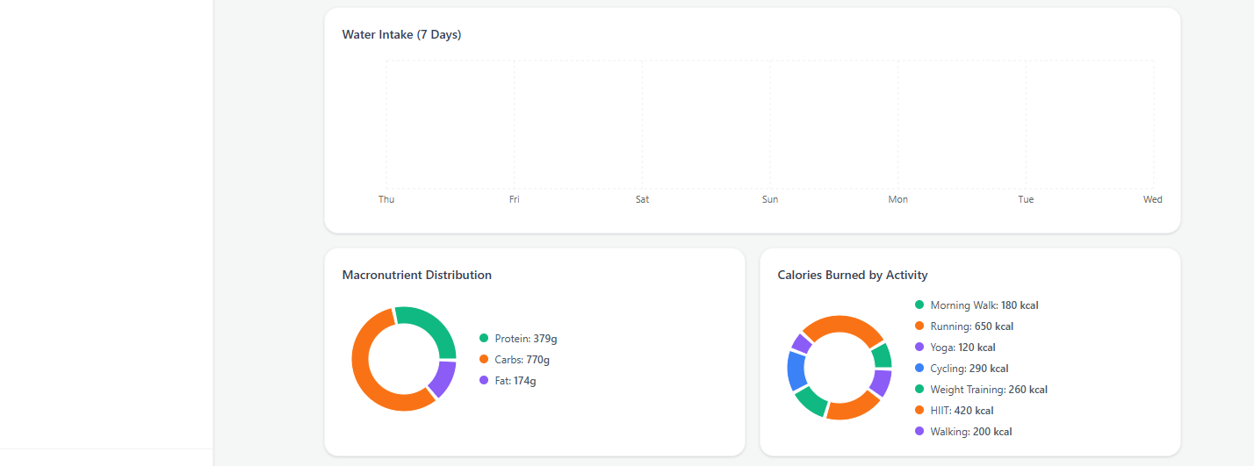
Sort by log type in log history | - Click the History tab  - Select Log Type ‘Activity’ | Log history shows only activity logs, hides all other logs | 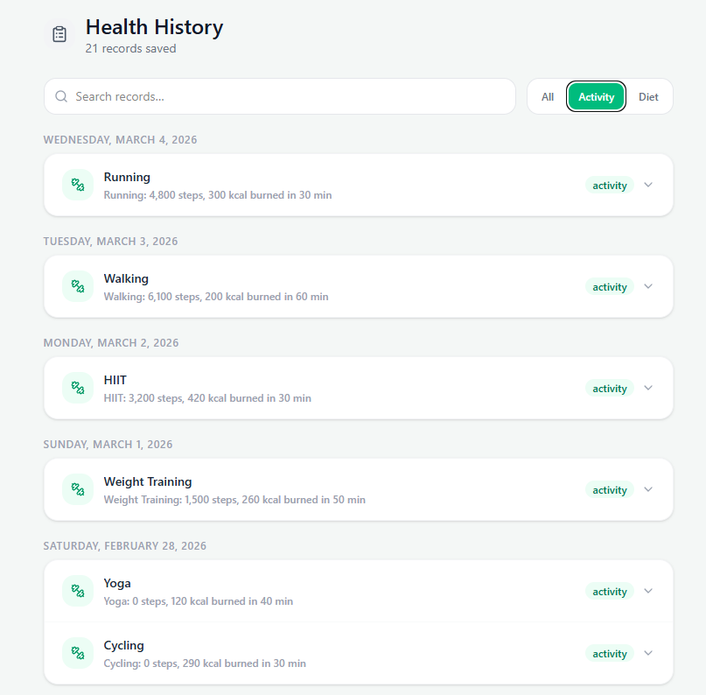
UI works on different resolutions | - Use Figma to check whether the UI still works on different resolutions. | The UI still works properly, and everything is clear and well organized | 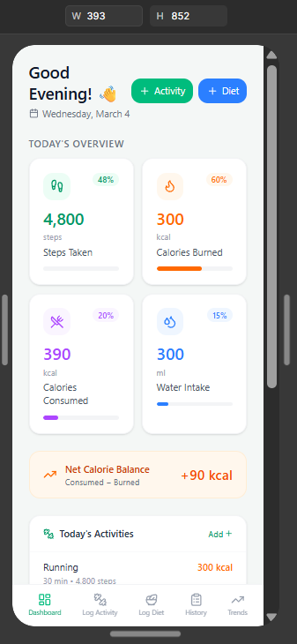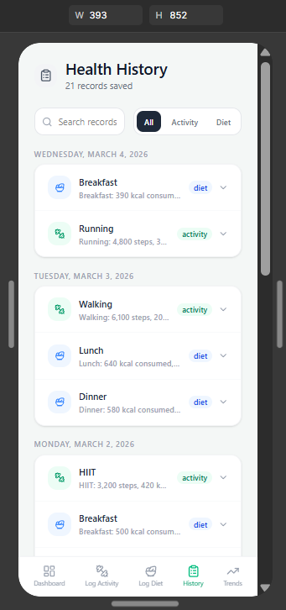
Prototype 2
Test | Steps | Result | Image(s)
Signup and login | - Click Sign up  - Enter username  - Enter password that is less than 6 characters  - Click create account  - Enter a password with 6 characters  - Click create account | Error pops up and lets the user know that the password must be at least 6 characters  Account is created after the password has at least 6 characters, user is automatically logged in | 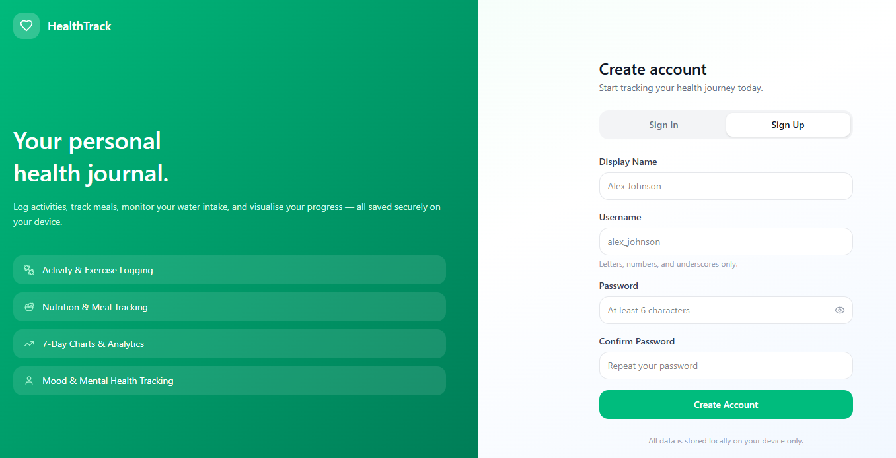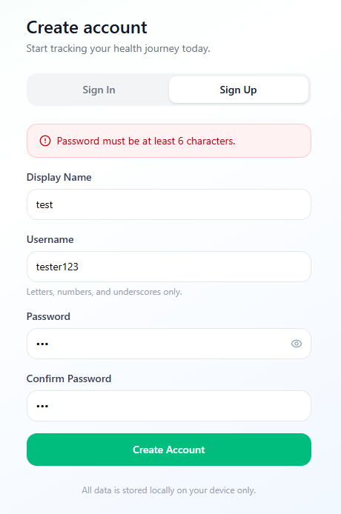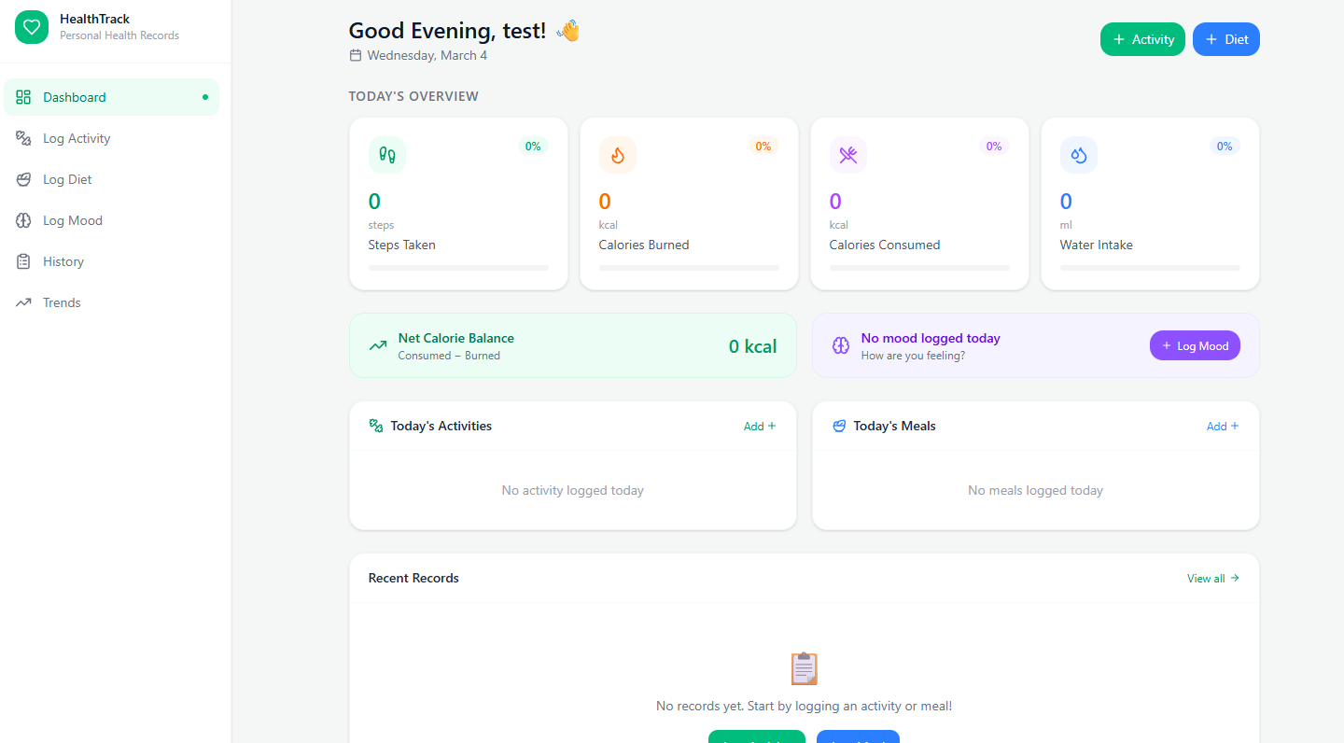
Create mood log | - Click Log mood tab  - Fill in details by clicking icons  - Click save mood entry | Mood entry is saved | 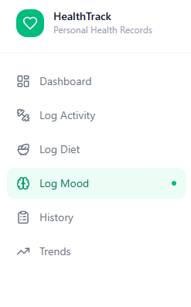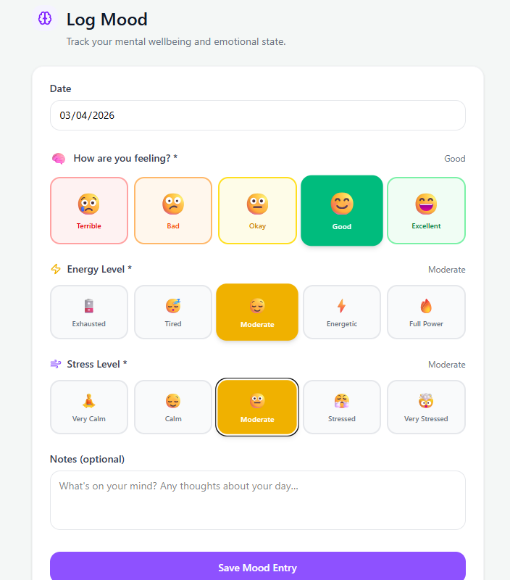
Delete mood log | - Click the History tab  - Select mood entry  - Click delete record  - Confirm delete | Mood entry is deleted and change is reflected in the data | 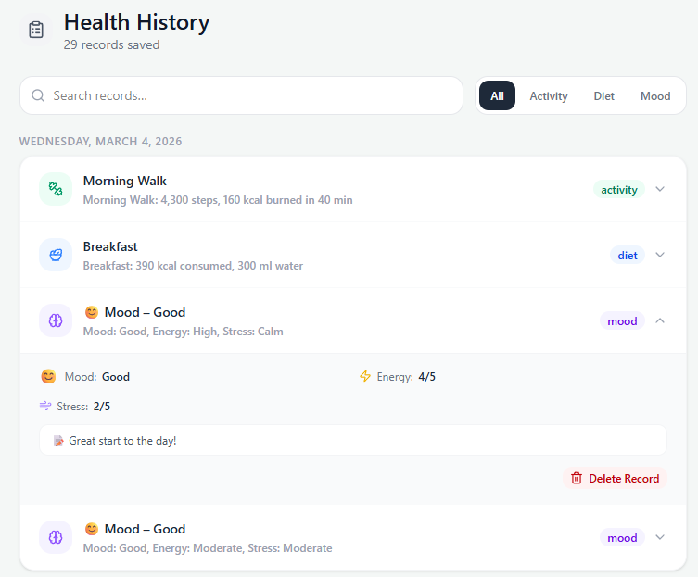
Trends and analytics are shown correctly | - Click Trends tab  - View charts | Charts are shown correctly and data is accurate following the history log | 